Yes it will

**From:** Caputo, Tony   
**Sent:** Thursday, May 03, 2018 2:30 PM  
**To:** Waters, Danny <[dwaters@harsco.com](mailto:dwaters@harsco.com)>; AXC Drafting Staff <[AXCDraftingStaff@harsco.com](mailto:AXCDraftingStaff@harsco.com)>  
**Cc:** Williams, Scott <[swilliams@harsco.com](mailto:swilliams@harsco.com)>  
**Subject:** RE: New Lifting Lug

Will this part and welded nut be added to the standard sideframe drawing?

**From:** Waters, Danny   
**Sent:** Thursday, May 03, 2018 2:08 PM  
**To:** AXC Drafting Staff <[AXCDraftingStaff@harsco.com](mailto:AXCDraftingStaff@harsco.com)>  
**Subject:** New Lifting Lug

Beginning with the next job you start we need to implement the new lifting lug design.

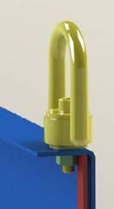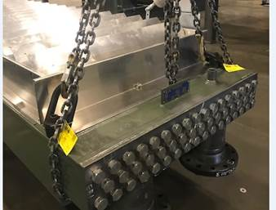 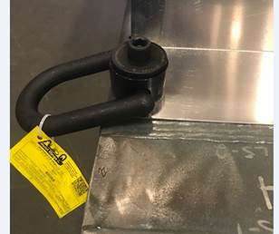

Criteria

1. If section is less than 28,000lbs and the customer does not specify lifting lugs there will not be a welded lug used.
2. If the customer specifies a lift lugs then a welded lug will be used along with the new design
3. Currently all Solar jobs will require both lugs.
4. This only applies to horizontal units.
5. These will only be used on broke channel side frames.

Design requirements:

1. A 13/16 dia hole will be located 1” from each end of the channel and will be on a 1 ½ ga.
2. Note 4 will need to be added.
3. The shutter will need to have a wider flange as show below
4. Hail guards will also require something similar to the shutters
5. There will be guide bars on each end of the channel regardless of welded or floating header.

**Side Frame**

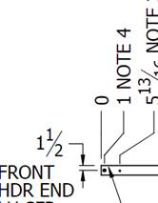

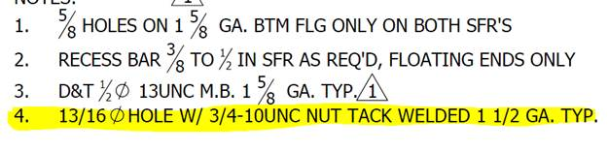

**Shutter**

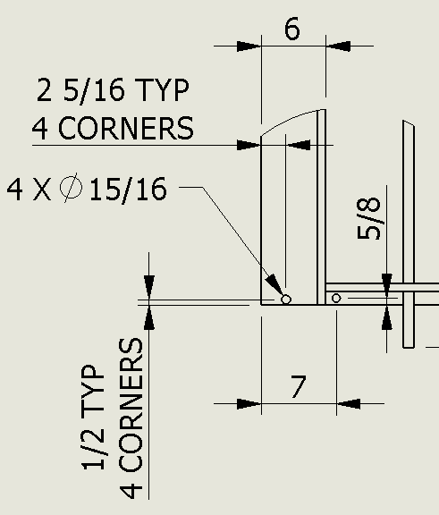

**Danny Waters |** Senior Designer

**Engineering and Design**

Harsco Industrial Air-X-Changers

Tulsa , OK USA══════════════════════════

Phone:918 619-8063 Cell:918 261-8643

[dwaters@harsco.com](mailto:dwaters@harsco.com) **|** [**www.harscoaxc.com**](http://www.harscoaxc.com/)